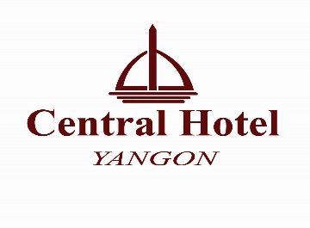

ROOM RESERVATIONS FORM

YANGON INTERNATIONAL GEMS & JEWELRY FAIR 2018 ( 11th – 14th Jan 2017 )
We are glad to receive your kind room booking in the following room reservation form.
Please send via email to rsv@centralhotelyangon.com, contact to +95 1 241001 ~ 20.

Personal Information

First Name
Last Name
Date of Birth ( DD/MM/YY)
Passport number/ Expiry Date
Contact number
E-mail address

Room Category & Bed type ( Please remark MARK in it )

Room Category | Double | Twin
Executive Suite
Royal Deluxe
Deluxe
Superior

We accept fresh notes in cash or credit card ( VISA, MASTER, CUP ( UPI ), MPU & JCB ).

- We serve daily buffet breakfast at Diamond White Restaurant ( from 06:00 to 09:30 )
- Free Wi-Fi Internet access in the whole hotel area
- Tea/Coffee Facilities in room
- Daily complimentary 02 bottles of Purified Drinking Water
- Complimentary Fresh Seasonal Fruit tray

Cancellation : Kindly cancel before one week ahead of check in date at hotel.

;

